PROJECT IMPLEMENTATION AND FINAL REPORT

**Introduction:**

The site is a single page site. More features to be added later.

It has a carousel to indicate dog breeds.

It has a jumbotron which has a button for users to sell, buy or request more information

It has cards to display various dog breeds available. Each would link to a specific page.

It has 2 forms for mating, and users interested in purchasing feed.

**Design and implementation**

The first step to implementing the design was to establish the framework. Then development of the individual sections followed.

The cards gave me challenges. I learnt the importance of getting images with uniform sizes and format.

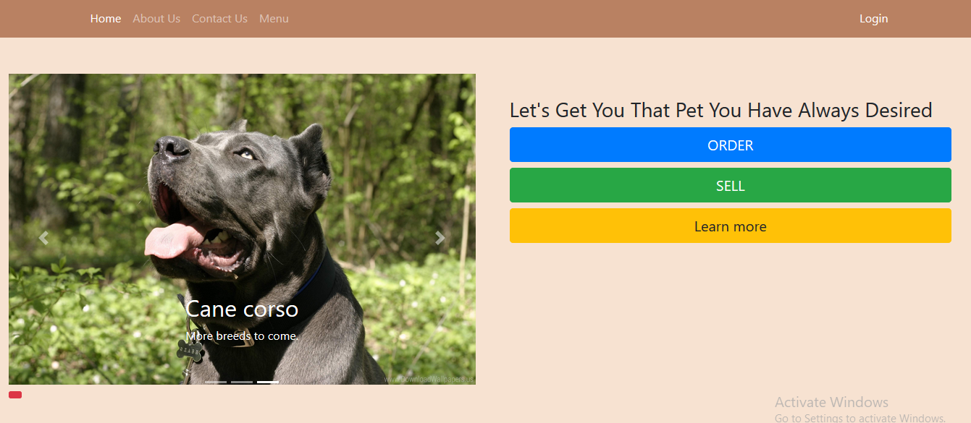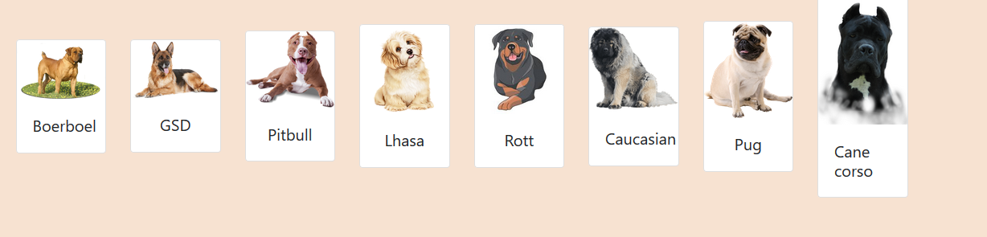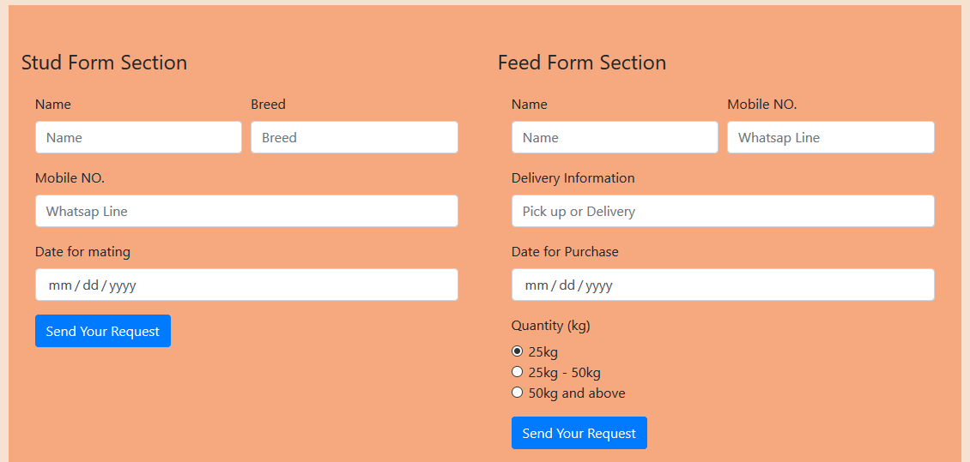

**CONCLUSION**

The result was satisfactory, with a nice colour theme.

Still had issues with the cards due to non-uniformity of image (will replace with other features)

Overall it’s a wonderful experience, and will definitely do more